**ABSTRACT**

Smart LED streetlight system is one of the enabling technologies for a smart city, giving low-cost, low power outdoor lighting also with benefits for vehicle users as well as pedestrians. Both safety and energy conservation are very important advantages of smart cities. Namely, the city street lamp is correlated with both safety and energy conservation.

Integration of sensors and wireless sensor modules can furnish an optimal platform for an innovative LED streetlight application. Psychological studies suggest that different level of color temperature can significantly affect human circadian rhythm. In this project to address the existing problems, a smart street lamp (SSL) based on decentralized computing for smart cities are proposed in this paper. The proposed SSL is dynamic brightness adjustment, all street lamps can be adjusted dynamically; autonomous alarm on abnormal states, each street lamp can report the abnormal status independently, such as broken, fault, and so on. Furthermore, real-time implementation of the proposed system shows perfect transmission-reception parameters such as throughput and signal strength among the different LED streetlights, which fulfils the wireless communication range and signal quality between each LED streetlights.

Energy conservation is an important matter as resources are decreasing at an alarming rate and this would create a lot of problems for the next generations. To overcome from this issue, a proper energy saving method and automatic lighting control needs to be implemented. This work proposes a model for modifying Street lights illumination using sensors at minimum electrical consumption as well as elimination of manual operation. In this work the LED lights are used as streetlights, LDR sensor is used for detecting light intensity for differentiating between daytime and night-time and IR sensors are used to sense vehicle movements. If presence is not detected, all nearby streetlights remain in the dim mode, which is 30% intensity for pedestrians, and only illuminate at 100% intensity when presence is detected. LED bulbs shall be used as they are better than conventional incandescent bulbs in every way. The intensity of LED can be controlled using PWM techniques. Through this proposed System the overall energy being utilized now-a-days for lighting is minimized. The automatic control of lighting is required to control the complex lighting system due to growth of cities and the Standard of Living.

**TABLE OF CONTENT**

|  |  |  |
| --- | --- | --- |
| S.NO | CHAPTER | PAGE NO |
| 1 | **PROJECT DESCRIPTION**   * 1. INTRODUCTION   2. EXISTING SYSTEM   3. PROPOSED SYSTEM      1. HARDWARE SPECIFICATION      2. SOFTWARE SPECIFICATION |  |
| 2 | **LOGICAL DEVELOPMENT**  2.1 DATAFLOW DIAGRAM  2.2 ARCHITECTURE DESIGN / BLOCK DIAGRAM |  |
| 3 | **PROGRAM DESIGN** |  |
| 4 | **TESTING** |  |
| 5 | **CONCLUSION** |  |
| 6 | **REFERENCES** |  |
|  | **APPENDICES**  SOURCE CODE  OUTPUT SCREEN SHOT |  |

**CHAPTER 1**

**PROJECT DESCRIPTION**

**1.PROJECT DESCRIPTION**

**1.1 INTRODUCTION**

The main aim of the smart city relates to safer, more convenient, and more comfortable operation, and better energy conservation. Therefore, make an urban infrastructure be smarter is necessary for promoting the smart cities. The street lamp as an essential part of urban infrastructure in the city, closely relates to the safety and energy conservation. Nowadays, it is impossible to imagine how the city would look like without street lamps. However, it is easy to predict that in that case the danger from traffic, robbery, and stealing would increase seriously. Moreover, it is necessary to optimize the current street lamp management because of its high energy consumption on daily basis.

The trend of global urbanization brings about advancement in the digital technologies and design of smart cities. Streetlight technology is one of the trend in the development of smart city. The application of streetlight is crucial and often found in the big or small cities all over the world. Streetlight can provide light at nighttime to the streets and public places, which can mitigate the probability of accident happening and enhance the safety of drivers and pedestrians.

Recently, the use of light-emitting diode (LED) lamp for streetlight has grown significantly. LED based streetlight technology has considerable advantages in terms of both energy efficiency and optical luminescence as compared to conventional streetlight technologies such as the high-pressure sodium (HPS) and low-pressure sodium (LPS) lamps. In addition to being eco-friendly due to its low electrical energy consumption, it also affords plenty of benefits, namely, uniformity of illumination levels via arrays of many LED chips, visibility of the streetlight through correlated color temperature (CCT), and visual performance improvement by virtue of high color rendering index. Even though LED streetlight has higher initial cost, it has a longer lifespan which makes the maintenance cost cheaper over the time compared to HPS streetlight. LED streetlight also produces less heat, which makes the physical design simpler, whereas HPS streetlight needs a proper cooling mechanism to keep its temperature in normal range. Thence, due to incredible promise of LED technology and also as part of smart city applications, many countries nowadays have started replacing the HPS/LPS lamp system by LED for both indoor and outdoor lighting systems.

**1.1.1 INTELLIGENT STREET LIGHTING**

Intelligent street lighting refers to public street lighting that adapts to movement by pedestrians, cyclists and cars. Intelligent street lighting, also referred to as adaptive street lighting, dims when no activity is detected, but brightens when movement is detected. This type of lighting is different from traditional, stationary illumination, or dimmable street lighting that dims at pre-determined times.

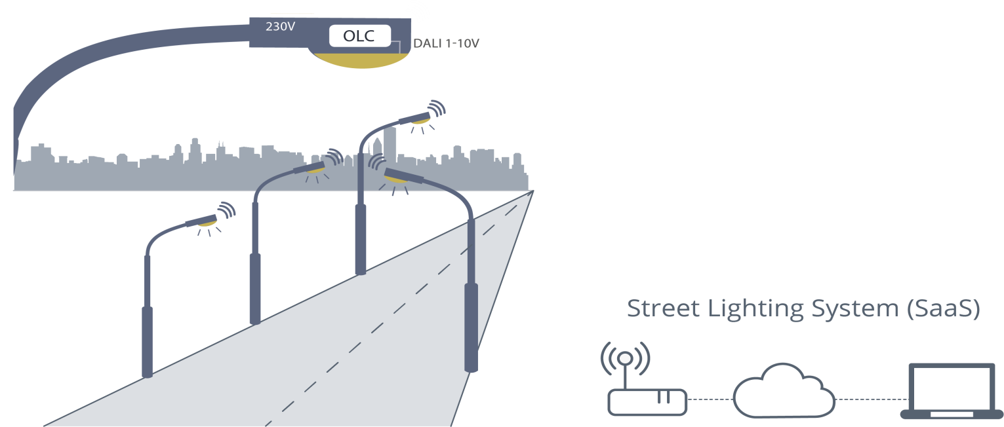

**Features**

Street lights can be made intelligent by placing cameras or other sensors on them, which enables them to detect movement (e.g. Sensitivity's Light Sensory Network, GE's "Currents"). Additional technology enables the street lights to communicate with one another. Different companies have different variations to this technology. When a passer-by is detected by a camera or sensor, it will communicate this to neighboring street lights, which will brighten so that people are always surrounded by a safe circle of light.

Some companies also offer software with which the street lights can be monitored and managed wirelessly. Clients, or other companies, can access the software from a computer, or even a tablet. From this software, they can gather data, pre-set levels of brightness and dimming time; receive warning signals when a light defects.

**1.1.2 CURRENT STREET LIGHTING SYSTEMS**

* Manual switching: This is the classic and omnipresent technique. The light is switched ON and OFF by a human attendant.
* Light dependent resistance (LDR): LDR-based lights can switch themselves ON and OFF according to the ambient light conditions. Tolerance variation in LDRs requires manual tuning of threshold levels in individual lights, typically using potentiometers. Dust deposits can also affect the sensitivity. Such factors reduce the reliability of the system.
* Astronomical Timers: These devices choose the switch ON or switch OFF time depending on the date on the calendar. The devices are pre-programmed according to the location of the installation. This scheme is inflexible, does not take care of variable light situations such as overcast, dust storm etc.

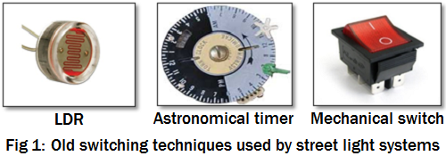

The above systems are simple, economical and easy to install. However, these are not flexible and do not lend themselves to modern power-saving strategies. They provide limited monitoring capabilities.

Street lights are doing more than ever in today’s smart cities. With digital networks and embedded sensors, they collect and transmit information that helps cities monitor and respond to any circumstance, from traffic and air quality to crowds and noise. They can detect traffic congestion and track available parking spaces. Those very same networks can remotely control LED lights to turn on and off, flash, dim and more, offering cities a chance to maximize low-energy lighting benefits while also improving pedestrian and bicyclist safety. With street lights creating a network canopy, those networks of data can be used by more than just lighting departments, empowering even schools and businesses via a lighting infrastructure that brightens the future of the digital city.

A smart street lamp (SSL) based on fog computing for smarter cities to meet the above four abilities. The proposed SSL consists of three main parts: an intelligent sensing street lamp, which can adjust lamp brightness, an autonomous alarm which reports about abnormal behaviour; an efficient network, which is used for real-time communication between managers and massive street lamps; and lastly, a flexible management platform, which is easy and highly automated.

**1.2 EXISTING SYSTEM**

The existing system describes about the circuit that switches the street light ON detecting the vehicle movement and remains OFF after the fixed time. In this system the street light automatically ON/OFF during the night and the day time. In this system the GSM technology has been used in which the manual switching OFF/ON of the street light using GSM. Here the system controls the intensity of the street light by dimming and brightness the intensity on the detection of any object using PIR sensor. And focused on the necessity of the automated street light system and the peculiar way of implementation with embedded system tools. In this system the piezo electric sensor is used to detect the movement of the object on the street instead of using IR sensor. A microcontroller msp430 as a brain to control the process involved.

**1.2.1 LIMITATIONS**

* Energy may be wasted
* Difficult to detect the object moving
* Unwanted events may not be occurred
* High communication cost

**1.3 PROPOSED SYSTEM**

Automate street lights are necessary while we are trying to survive in the era of smart world. As automation provides perfection and efficiency. In this paper we are focusing on automated street lighting, as current system is facing many problems. Here we are considering the problems which are done manually. A user has to deal with numerous problems like maintenance problem, timer problem, connectivity problem, display problem. Streetlights are among a city’s strategic assets, providing safe roads, inviting public areas, and enhanced security in homes, businesses, and city centres.

This project gives a solution to the controlling the intensity of the light considering the movement on the road. Then designed to detect the vehicle movement on the highways to switch ON only a block of the street light ahead of it and switch OFF the trailing light to save energy. During the night all the lights on the highways remain ON for the vehicle, but lot of energy is wasted when there is no vehicle movement on the highways. In this existing system two kind of sensors has been used which are light sensor, photo electric sensor. The system with LDR sensor, PIR sensor, Zigbee is used to intimate the status of humans use, light intensity and street light ON/OFF status to the EB section to avoid wastage of energy by glowing street lights in unwanted areas. The whole system is operated by using artificial energy source called solar and with battery backup. Depend upon the data received the controller will turn ON/OFF the street light in wireless communication. This system is appropriate for street lighting in remote urban and rural areas where the traffic is low at times.

**1.3.1 HARDWARE SPECIFICATION**

* Microcontroller
* IR sensor
* LDR
* Wi-Fi
* LCD display
* Power supply

**1.3.2 SOFTWARE SPECIFICATION**

* Software Specification:
  + Arduino IDE
  + Cloud implementation

A microcontroller is a small computer on a single integrated circuit that contains a processor core, memory, and programmable input/output peripherals. It is designed to perform specific tasks and is commonly used in embedded systems, such as controlling household appliances, automotive systems, medical devices, and industrial machinery. Microcontrollers are distinguished from microprocessors, which are the central processing units (CPUs) found in desktop computers and laptops, by their integrated peripherals and their ability to operate on small amounts of power. They can be programmed using various programming languages and development tools to carry out a wide range of functions.

**An IR (infrared) sensor is a type of electronic device that detects and measures infrared radiation. Infrared radiation is a form of electromagnetic radiation that is not visible to the human eye but can be sensed by certain electronic components, including IR sensors.**

**IR sensors typically consist of an emitter and a receiver. The emitter releases a steady beam of infrared light, while the receiver detects any changes in the emitted light caused by reflections or interruptions. When an object comes within the range of the IR sensor, it reflects or interrupts the infrared light, which is then detected by the receiver.**

**IR sensors are commonly used in a wide range of applications, including:**

1. **Proximity sensing: IR sensors can be used to detect the presence of objects within a certain range, such as in automatic faucets or hand dryers in public restrooms.**
2. **Object detection: IR sensors can detect the presence, position, or movement of objects, like in automatic doors or security systems.**

**3. Ambient light sensing: IR sensors can measure the intensity of ambient light in a room, allowing for automatic adjustment of display brightness or turning on/off lights.**

**4. Line-following robots: IR sensors can be used in robotics to track and follow lines on the ground, enabling autonomous movement.**

**IR sensors offer several advantages, such as low power consumption, compact size, and non-contact detection. They are relatively inexpensive and can be integrated into various electronic systems for a wide range of applications.**

**CHAPTER 2**

**LOGICAL DEVELOPMENT**

**2.2 ARCHITECTURE DESIGN / BLOCK DIAGRAM**

µC

LDR Sensor

Object Sensor

Power Supply

Driver

LED 1

LCD

**2.2 Hardware Descriptions**

**2.2.1 Arduino Nano**

The Arduino Nano is a small, complete, and breadboard-friendly board based on the ATmega328P. It offers the same connectivity and specs of the UNO board in a smaller form factor.

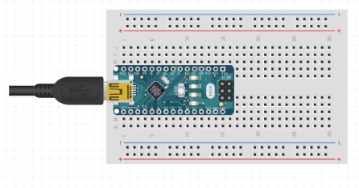

Fig 1: Arduino NANO Interface

The Arduino Nano is programmed using the Arduino Software (IDE), our Integrated Development Environment common to all our boards and running both online and offline. For more information on how to get started with the Arduino Software visit the Getting Started page.

Arduino Nano has similar functionalities as Arduino Duemilanove but with a different package. The Nano is inbuilt with the ATmega328P microcontroller, same as the Arduino UNO. The main difference between them is that the UNO board is presented in PDIP (Plastic Dual-In-line Package) form with 30 pins and Nano is available in TQFP (plastic quad flat pack) with 32 pins. The extra 2 pins of Arduino Nano serve for the ADC functionalities, while UNO has 6 ADC ports but Nano has 8 ADC ports. The Nano board doesn’t have a DC power jack as other Arduino boards, but instead has a mini-USB port. This port is used for both programming and serial monitoring. The fascinating feature in Nano is that it will choose the strongest power source with its potential difference, and the power source selecting jumper is invalid.

* **Arduino Nano Pinout Description**

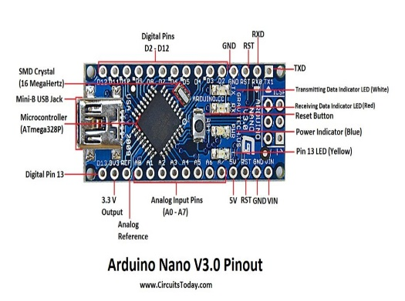

Fig 2: Arduino Nano pin Description

**2.2.2 LCD (Liquid Crystal Display)**

LCD (Liquid Crystal Display) screen is an electronic display module and find a wide range of applications. A 16x2 LCD display is very basic module and is very commonly used in various devices and circuits. A 16x2 LCD means it can display 16 characters per line and there are 2 such lines. In this LCD each character is displayed in 5x7 pixel matrix. This LCD has two registers, namely, Command and Data. The command register stores the command instructions given to the LCD, The data register stores the data to be displayed on the LCD

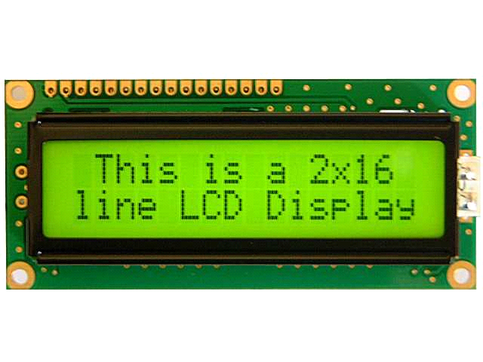

Fig 3: LCD Display

**2.2.3 LED (LIGHT EMITTING DIODE)**

Light Emitting Diodes or simply LED´s, are among the most widely used of all the different types of semiconductor diodes available today and are commonly used in TV’s and colour displays. They are the most visible type of diode, that emit a fairly narrow bandwidth of either visible light at different coloured wavelengths, invisible infra-red light for remote controls or laser type light when a forward current is passed through them.

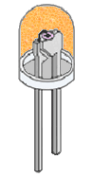

Fig 4: LED

The “Light Emitting Diode” or LED as it is more commonly called, is basically just a specialised type of diode as they have very similar electrical characteristics to a PN junction diode. This means that an LED will pass current in its forward direction but block the flow of current in the reverse direction.

Light emitting diodes are made from a very thin layer of fairly heavily doped semiconductor material and depending on the semiconductor material used and the amount of doping, when forward biased an LED will emit a coloured light at a particular spectral wavelength.

**2.3 Software Description**

* **Arduino Software (Ide)**

The Arduino Integrated Development Environment - or Arduino Software (IDE) - contains a text editor for writing code, a message area, a text console, a toolbar with buttons for common functions and a series of menus. It connects to the Arduino hardware to upload programs and communicate with them.

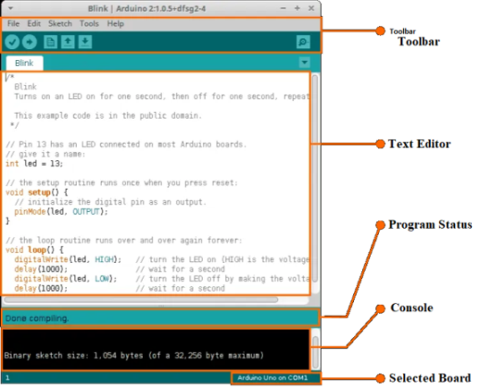

Fig 5: Arduino IDE

**2.3. EXPERIMENTAL RESULTS**

**2.4 Results**

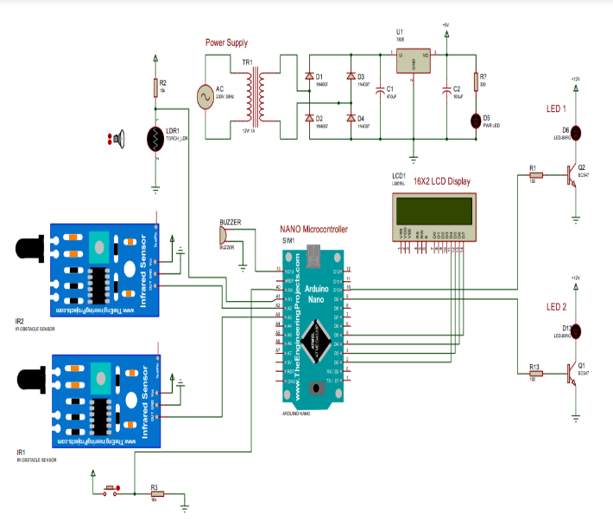

Fig 6: Proposed Circuit diagram

**2.4.1 Connection**

As shown in Fig. In the day time, LDR (light depending resistor ) will not work, due to the high intensity of a sun light, a high resistance of LDR is ultimately leads to open circuits and IR will also work but the street light will not turn ‘ON’. But at night the intensity will be low the resistance of LDR ultimately leads to close circuit. LDR sensor will send the signal to the Arduino and when the object pass through the IR sensor then it will send the signal to the Arduino. Arduino is the main controller to control all sensors, when sensor will send the value as output to Arduino, it will receive and LED will be ‘HIGH’, till when the object pass through it and again the LED will be ‘LOW

**2.LOGICAL DEVELOPMENT**

**2.1 DATAFLOW DIAGRAM**

A Data Flow Diagram (DFD) is a graphical representation of the “flow” of data through an information system. DFD’s can be used for visualization of data processing. Using a DFD, users can visualize how the system will operate, what the system will accomplish, and how the system will be implemented.

|  |  |
| --- | --- |
| **Symbols** | **Description** |
|  | A rectangle defines an entity |
|  | A circle shows process within the system |
|  | An arrow shows the flow of information |
|  | A data store shows the holding place of the information |

**Level 0**

Output Street Light

Check Data

Input

Sensor

Arduino NANO

**Level 1**

Check Data

Object Detection

Based On Light Value

LED Brightness

ON OFF Control

**CHAPTER 3**

**DATABASE DESIGN**

**3. DATABASE DESIGN**

**3.1 Embedded C**

Using integrated C in the database backend is essential for effective data handling and connectivity among IoT devices & the central database when it comes to IoT-based remote plant monitoring. In this case, the C programming language's embedded system-optimized counterpart, Embedded C, has various benefits. First of all, it can execute code efficiently and light-weight, which makes it appropriate for limited in resources IoT devices like those often found in remote factory monitoring networks. Real-time plant condition monitoring and analysis are made possible by embedded C's ability to interface with the database backend and enable the smooth incorporation of IoT sensor data into the database. Furthermore, the low-level control capabilities of embedded C enable accurate data processing and manipulation, guaranteeing the precision and dependability of the gathered data. Additionally, embedded C supports simple communication protocols like MQTT and CoAP that are frequently used in Internet of Things applications. This allows sensor data to be efficiently transmitted to the database back over network connections with no overhead. Overall, reliable, scalable, and immediate surveillance solutions catered to the particular requirements of plant management & optimization in remote situations are made possible by the integration of embedded C into the database's backend for distant plant monitoring utilizing IoT.

**CHAPTER 4**

**PROGRAM DESIGN**

**3.PROGRAM DESIGN**

**3.1 MODULES**

* Input Sensor Module
* Light Monitoring Module
* Power Supply
* Output Module

**3.2 MODULE DESCRIPTION**

* **Input Sensor Module**

The Input Sensor Module acts as the backbone of the street light monitoring system, orchestrating the delicate balance between adequate illumination and energy conservation. By harnessing an array of advanced sensors including light intensity, motion, and ambient temperature detectors, this module remains vigilant, continuously monitoring the dynamic environment. With this real-time data at its disposal, the module can make informed decisions about when and how to adjust street light brightness levels. Whether it's the gradual onset of twilight or sudden bursts of motion indicating activity, the sensors serve as vigilant sentinels, ensuring that streets remain well-lit when necessary while conserving energy during quieter periods.

The versatility of the Input Sensor Module allows it to respond swiftly and intelligently to a myriad of environmental cues. When daylight wanes or external motion is detected, signaling the presence of pedestrians or vehicles, the sensors spring into action, communicating with the central control unit to enact appropriate lighting adjustments. This dynamic response mechanism ensures that streets are adequately illuminated to guarantee optimal visibility and safety for road users. Moreover, by modulating street light brightness based on real-time conditions, the system minimizes unnecessary energy expenditure, contributing to overall sustainability efforts.

The Input Sensor Module's seamless integration with the central control unit is pivotal in realizing the broader objectives of safety enhancement and energy efficiency. By relaying comprehensive data streams for analysis and decision-making, this module empowers the system to proactively manage lighting infrastructure across urban landscapes. Consequently, not only does it mitigate safety risks by ensuring well-lit pathways, but it also fosters a more sustainable approach to urban lighting. Through its judicious control of street light brightness in response to changing environmental dynamics, the Input Sensor Module plays a crucial role in reducing energy consumption, thereby contributing to the overarching goal of creating greener, smarter cities.

* **Light Monitoring Module**

The Light Monitoring Module stands as a cornerstone within the street light monitoring system, tasked with the comprehensive oversight of illumination levels across urban environments. Equipped with sophisticated sensors and monitoring mechanisms, this module continually assesses ambient light conditions to ensure optimal visibility and safety for pedestrians and motorists alike. By leveraging a combination of light intensity sensors, photodiodes, and spectral analysis tools, the module captures nuanced variations in natural and artificial light sources, enabling precise adjustments to street light brightness levels. This proactive approach not only enhances public safety by maintaining consistent illumination but also facilitates energy efficiency by dynamically adapting to changing environmental factors such as weather conditions and seasonal variations.

At the heart of the Light Monitoring Module lies its capacity for real-time data analysis and adaptive control strategies. Through seamless integration with the central monitoring system, this module continuously transmits sensory data streams for rapid processing and decision-making. By employing advanced algorithms and machine learning techniques, the module can discern patterns in light intensity fluctuations, identify anomalies, and predict future lighting requirements with remarkable accuracy. Whether responding to sudden drops in ambient light during dusk or optimizing energy consumption during low-traffic hours, the module's agile responsiveness ensures that urban lighting infrastructure remains finely tuned to the needs of its environment.

By virtue of its vigilance and adaptability, the Light Monitoring Module plays a pivotal role in driving overarching objectives of safety, efficiency, and sustainability within urban lighting ecosystems. Through its proactive management of street light brightness levels based on real-time data insights, the module mitigates safety hazards associated with inadequate illumination and enhances overall visibility for road users. Furthermore, its judicious control of energy consumption not only reduces operational costs but also contributes to broader sustainability initiatives by minimizing carbon emissions and resource depletion. Ultimately, by optimizing the balance between safety, efficiency, and environmental impact, the Light Monitoring Module emerges as a linchpin in the pursuit of smarter, more resilient urban lighting infrastructures.

* **Power Supply**

The Power Supply component serves as the vital lifeline of the street light monitoring system, providing the necessary electrical energy to sustain its operation around the clock. Engineered for reliability and resilience, this infrastructure is designed to withstand the rigors of outdoor environments while delivering uninterrupted power to critical system components. Leveraging a combination of grid-connected mains electricity, renewable energy sources such as solar panels, and battery backup systems, the Power Supply ensures continuity of service even in the event of grid failures or adverse weather conditions. By adopting a multi-layered approach to power provision, the system mitigates the risk of downtime and safeguards against disruptions in urban lighting services, thereby enhancing public safety and operational efficiency.

Beyond mere provision of power, the Power Supply component embodies a commitment to efficient energy management and optimization within the street light monitoring system. Through intelligent load balancing algorithms and voltage regulation mechanisms, this infrastructure optimizes energy distribution across the network, minimizing wastage and maximizing utilization. Additionally, integration with smart grid technologies enables real-time monitoring of energy consumption patterns, facilitating proactive adjustments to power delivery based on demand fluctuations and system requirements. By promoting energy efficiency and reducing overall power consumption, the Power Supply component not only lowers operational costs but also contributes to broader sustainability goals by reducing carbon emissions and environmental impact associated with traditional lighting infrastructures.

* **Output Module**

Dynamic Control and Regulation of Street Lights: The Output Module is the final link in the chain of the street light monitoring system, responsible for the dynamic control and regulation of street lights based on inputs received from various sensors and the central control unit. Equipped with intelligent controllers and actuators, this module translates commands and instructions into tangible actions, orchestrating the illumination of urban thoroughfares with precision and efficiency. By interfacing directly with individual street light fixtures or groups of lights, the Output Module enables granular control over brightness levels, timing schedules, and adaptive lighting strategies. Whether dimming lights during periods of low pedestrian activity to conserve energy or intensifying illumination in response to safety-critical situations, this module ensures that street lighting remains responsive to the evolving needs of urban environments.

Ultimately, the Output Module plays a crucial role in enhancing visibility, safety, and overall user experience within urban environments. By delivering consistent and reliable illumination levels across streets, sidewalks, and public spaces, this module promotes pedestrian safety, deters criminal activities, and fosters a sense of security among residents and visitors alike. Moreover, through its support for adaptive lighting schemes and dynamic brightness adjustments, the Output Module creates more comfortable and inviting urban landscapes, enhancing the livability and attractiveness of cities at night. Whether illuminating bustling commercial districts, residential neighborhoods, or remote rural roads, this module ensures that street lighting remains a cornerstone of vibrant, inclusive, and sustainable urban communities.

**CHAPTER 4**

**TESTING**

**4.TESTING**

Software testing is a method of assessing the functionality of a software program. There are many different types of software testing but the two main categories are dynamic testing and static testing. Dynamic testing is an assessment that is conducted while the program is executed; static testing, on the other hand, is an examination of the program's code and associated documentation. Dynamic and static methods are often used together.

The data is entered in all forms separately and whenever an error occurred, it is corrected immediately. A quality team deputed by the management verified all the necessary documents and tested the Software while entering the data at all levels. The development process involves various types of testing. Each test type addresses a specific testing requirement. The most common types of testing involved in the development process are:

• Unit Test.

• System Test

• Integration Test

• Functional Test

**TYPES OF TESTING**

**UNIT TESTING:**

The first test in the development process is the unit test. The source code is normally divided into modules, which in turn are divided into smaller units called units. These units have specific behavior. The test done on these units of code is called unit test. Unit test depends upon the language on which the project is developed. Unit tests ensure that each unique path of the project performs accurately to the documented specifications and contains clearly defined inputs and expected results. Functional and reliability testing in an Engineering environment. Producing tests for the behavior of components (nodes and vertices) of a product to ensure their correct behavior prior to system integration.

**FUNCTIONAL TESTING:**

Functional test can be defined as testing two or more modules together with the intent of finding defects, demonstrating that defects are not present, verifying that the module performs its intended functions as stated in the specification and establishing confidence that a program does what it is supposed to do.

**INTEGRATION TESTING:**

Testing in which modules are combined and tested as a group. Modules are typically code modules, individual applications, source and destination applications on a network, etc. Integration Testing follows unit testing and precedes system testing. Testing after the product is code complete. Betas are often widely distributed or even distributed to the public at large in hopes that they will buy the final product when it is released.

**WHITE BOX TESTING:**

Testing based on an analysis of internal workings and structure of a piece of software. This testing can be done sing the percentage value of load and energy. The tester should know what exactly is done in the internal program. Includes techniques such as Branch Testing and Path Testing.Also known as Structural Testing and Glass Box Testing.

**BLACK BOX TESTING:**

Testing without knowledge of the internal workings of the item being tested. Tests are usually functional. This testing can be done by the user who has no knowledge of how the shortest path is found.

**SYSTEM TESTING**

Testing is a set activity that can be planned and conducted systematically. Testing begins at the module level and work towards the integration of entire computers based system. Nothing is complete without testing, as it is vital success of the system.

• **Testing Objectives:**

There are several rules that can serve as testing objectives, they are

1. Testing is a process of executing a program with the intent of finding an error
2. A good test case is one that has high probability of finding an undiscovered error.
3. A successful test is one that uncovers an undiscovered error.

If testing is conducted successfully according to the objectives as stated above, it would uncover errors in the software. Also testing demonstrates that software functions appear to the working according to the specification, that performance requirements appear to have been met.

There are three ways to test a program

1. For Correctness
2. For Implementation efficiency
3. For Computational Complexity.

Tests for correctness are supposed to verify that a program does exactly what it was designed to do. This is much more difficult than it may at first appear, especially for large programs.

Tests for implementation efficiency attempt to find ways to make a correct program faster or use less storage. It is a code-refining process, which reexamines the implementation phase of algorithm development. Tests for computational complexity amount to an experimental analysis of the complexity of an algorithm or an experimental comparison of two or more algorithms, which solve the same problem.

**CHAPTER 5**

**CONCLUSION**

**5. CONCLUSION**

The Streetlight controller using ldr based Light intensity & traffic density, in the todays up growing countries will be more effective in case of cost, manpower and security as compare with today's running complicated and complex light controlling systems. Automatic Street Light Controlling System puts up a very user friendly approach and could increase the power This paper elaborates the design and construction of automatic street control system circuit. Circuit works properly to turn street lamp ON/OFF. After designing the circuit which controls the light of the street as illustrated in the previous sections. LDR sensor and the photoelectric sensors are the two main conditions in working the circuit. If the two conditions have been satisfied the circuit will do the desired work according to specific program. Each sensor controls the turning ON or OFF the lighting column. The street lights has been successfully controlled by microcontroller. With commands from the controller the lights will be ON in the places of the movement when it's dark. furthermore the drawback of the street light system using timer controller has been overcome, where the system depends on photoelectric sensor.

**CHAPTER 6**

**REFERENCES**

1. **REFERENCES**
2. C. Atıcı, T. Özçelebi, JJ. Lukkien, “Exploring User-Centered IntelligentRoad Lighting Design: A Road Map and Future Research Directions,” IEEE Transactions on Consumer Electronics, vo. 57, pp. 788-793, 2011.
3. MS, Pan, LW, Yeh, YA Chen, YH Lin, YC Tseng, “A WSN-based intelligent light control system considering user activities and profiles,’ IEEE Sensor Journal, vol. 8, pp. 1710–1721, 2008.
4. S. Li, A. Pandharipande, “Networked Illumination Control WithDistributed Light-Harvesting Wireless Sensors,’ IEEE Sensor Journal, vol. 15, no. 3, pp. 1662-1669, 2015.
5. Z. Kaleem, I. Ahmad and C. Lee, "Smart and Energy Efficient LED Street Light Control System Using ZigBee Network," 2014 12thInternational Conference on Frontiers of Information Technology, Islamabad, 2014, pp. 361-365.
6. F. Leccese, M. Cagnetti, and D. Trinca, “A Smart City Application: A Fully Controlled Street Lighting Isle Based on Raspberry-Pi Card, a ZigBee Sensor Network and WiMAX,” Sensors,vol. 14, pp. 24408-24424, 2014.
7. P. Mlynek, J. Misurec, J. Kolka, Z. Slacik, and R. Fujdiak, “Narrowband Power Line Communication for Smart Metering and Street Lighting Control,” IFAC-PapersOnLine, 2015, vol. 48, pp. 215–219.
8. Ozadovics and J. Grela, “Energy saving in the street lighting control system—a new approach based on the EN-15232 standard,” EnergyEfficiency, DOI: 10.1007/s12053-016-9476-1, 2016.

8. Pooja Dagade, Priyanka Salunke, Supriya Salunke , Seema T. PatiL, Nutan Maharashtra

Institute of Engineering and Technology. Accident Detection & Ambulance Rescue

System Using Wireless ,IJRET,2017

9. R.Sivakumar, G. Vignesh, Vishal Narayanan, Anna University, Tamil Nadu. Automated

traffic light control system and stolen vehicle detection. IEEE, 2018.

10. Madhav Mishra, Seema Singh, Dr. Jayalekshmi K.R, Dr. Taskeen Nadkar. Advance

Alert for Ambulance Pass by using IOT for Smart City, International Journal of

Engineering Science and Computing, June 2017.

**APPENDIX**

**SOURCE CODE:**

//Header File

#include <LiquidCrystal.h>

LiquidCrystal lcd(7,6,5,4,3,2);

#define pwm 9

int incomingByte = 0;

int ldrv= A1;

int ldr = 0;

void setup() {

// put your setup code here, to run once:

pinMode(ldrv, INPUT);

delay(100);

Serial.begin(9600);

lcd.begin(16, 2);

lcd.setCursor(0,0);

lcd.print("SMART STREET ");

lcd.setCursor(0,1);

lcd.print("LIGHT CONTROL");

delay(2000);

lcd.clear();

}

void loop() {

// put your main code here, to run repeatedly:

ldr = analogRead(ldrv);

//ldr = ldr/2;

serial_read();

lcd.setCursor(0,1);

lcd.print("STA: 10");

analogWrite(pwm, 10);

lcd.setCursor(0,1);

lcd.print("STA: 25 ");

analogWrite(pwm, 50);

delay(1000);

lcd.setCursor(0,1);

lcd.print("STA: 50 ");

analogWrite(pwm, 100);

delay(1000);

lcd.setCursor(0,1);

lcd.print("STA: 70");

analogWrite(pwm, 150);

delay(1000);

lcd.setCursor(0,1);

lcd.print("STA: 90 ");

analogWrite(pwm, 180);

delay(1000);

lcd.setCursor(0,1);

lcd.print("STA: 100 ");

analogWrite(pwm, 250);

delay(1000);

}

void serial_read()

{

if (Serial.available() > 0)

{

incomingByte = Serial.read();

}

switch(incomingByte)

{

case '0':

delay(10);

analogWrite(pwm, 50);

lcd.setCursor(0,1);

lcd.print("STA: NO OBJECT ");

delay(100);

incomingByte='*';

break;

case '1':

delay(10);

analogWrite(pwm, 250);

lcd.setCursor(0,1);

lcd.print("OBJECT DETECTED ");

incomingByte='*';

break;

incomingByte='*';

break;

}

}

**SCREEN SHOTS AND REPORTS**

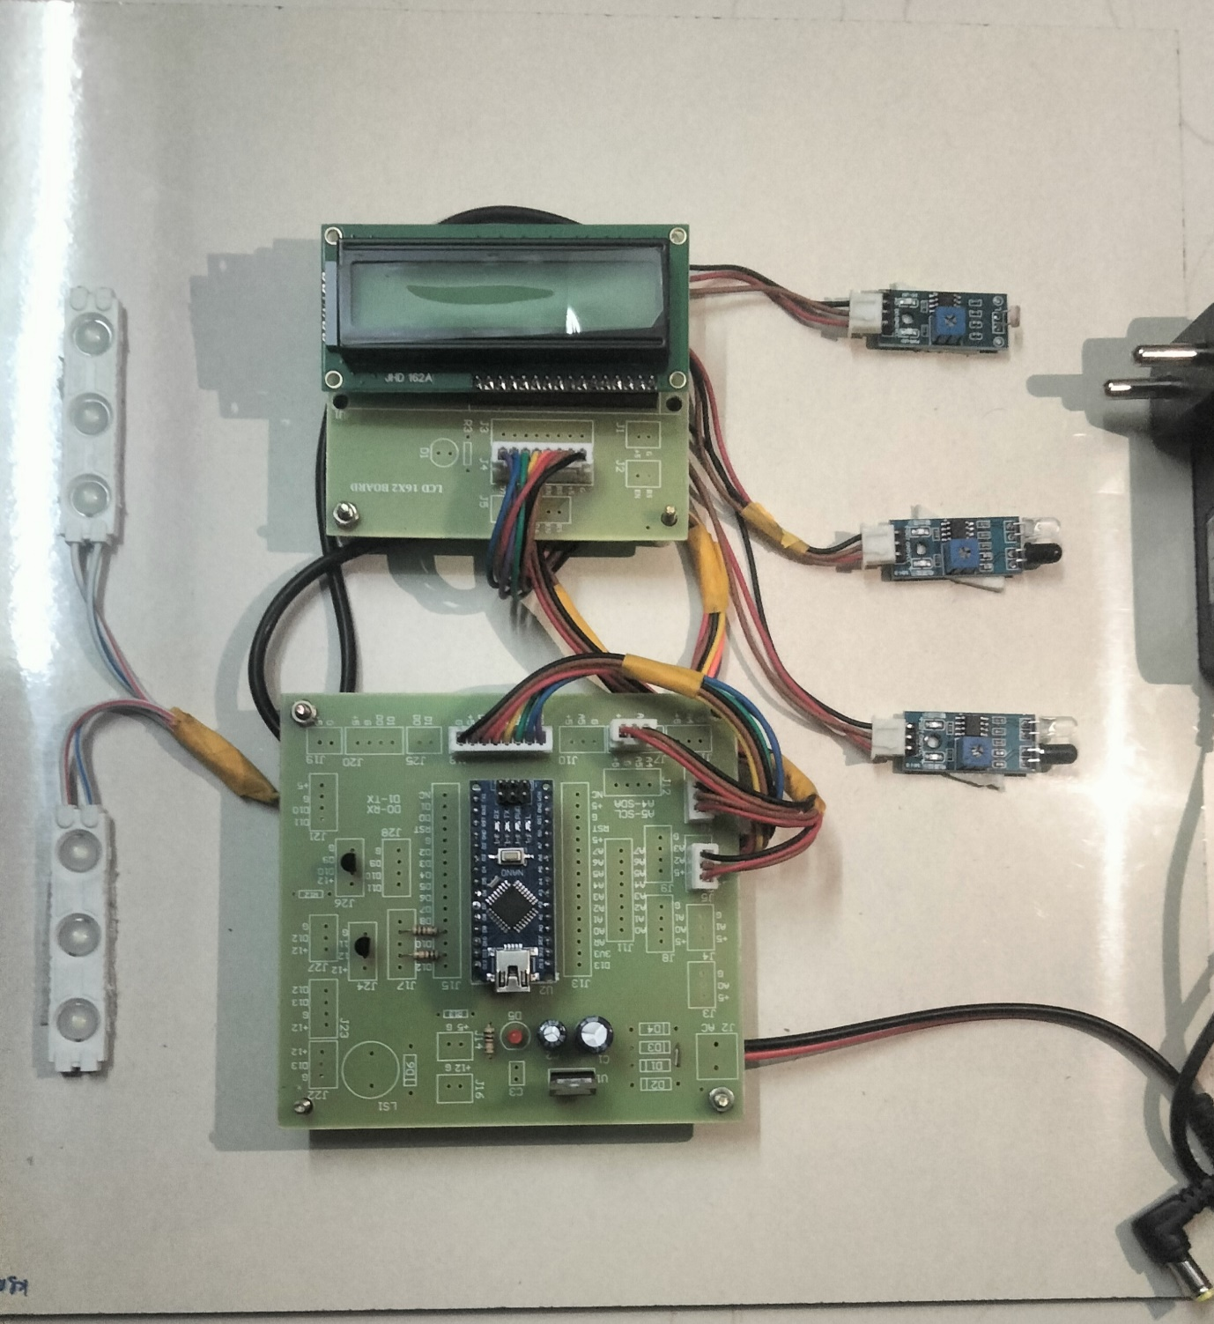**Output Figure**

**Fig1**

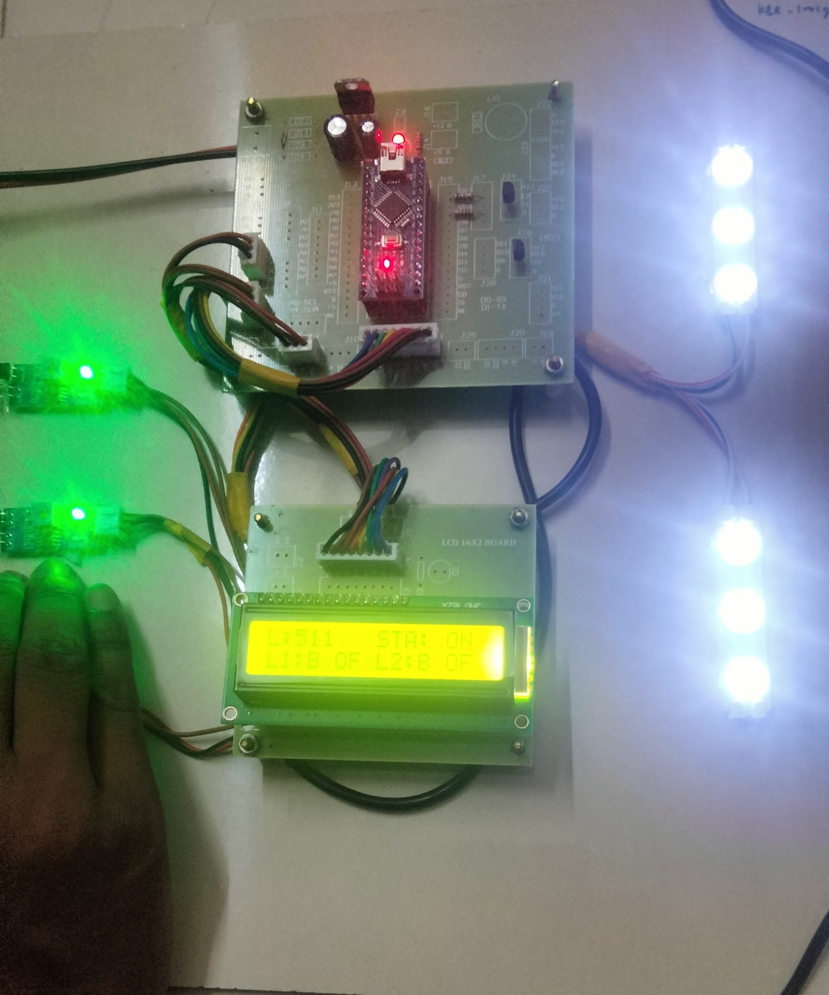

**Fig2**

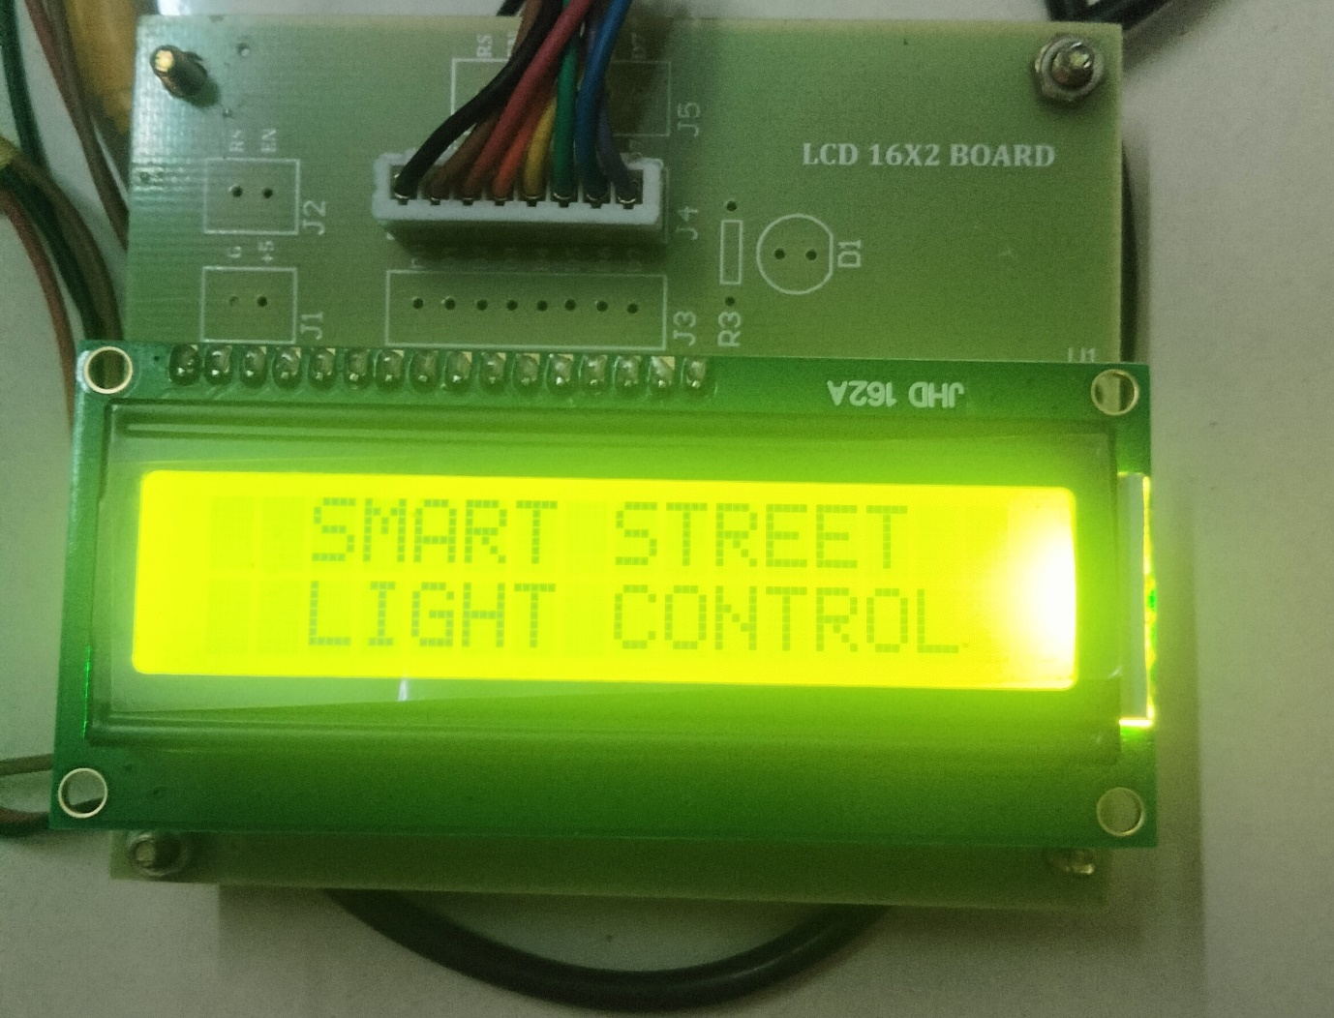**Output Figure**

